Testing the WEB UI by giving required inputs

|  |  |
| --- | --- |
| **Date** | **17 November 2022** |
| **Team ID** | **PNT2022TMID25665** |
| **Project Name** | **Smart Solutions for Railways** |

**Node RED WEBPAGE**

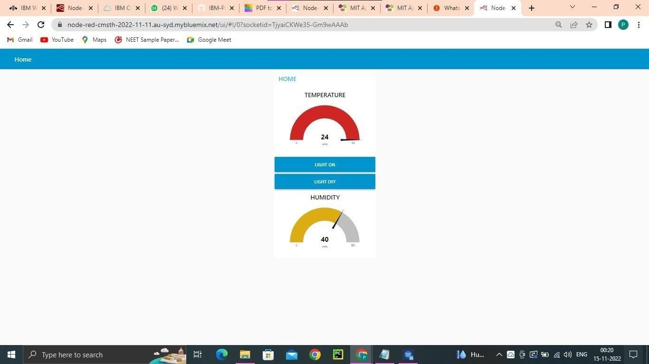

**MIT APP TO GET DATA AND TURN ON /OFF LIGHT**

